Lab 10: Blind SQL injection - Timebase SQL Injection
Objective:
- This lab is dedicated to exploring Time-Based SQL Injection, a subtype of SQL injection attacks where the attacker can infer information from a database by observing the response time of the web application. Participants will interact with a simulated web application that has a time-based SQL injection vulnerability. The goal is to understand the mechanics of this attack, identify vulnerabilities, exploit them, and learn effective mitigation strategies.
In this lab, students need to:
- Answer the following questions:
  - What distinguishes Time-Based SQL Injection from other SQL injection techniques? Explain how an attacker can use time delays in SQL queries to extract information from a database, and why this method is particularly useful when dealing with blind SQL injection scenarios where no data is returned in the web application's responses.
  - Describe the process of executing a Time-Based SQL Injection attack on a vulnerable web application. What are the key steps in crafting a SQL query that causes a deliberate delay in the database response.
- Perform challenge:
  - Blind SQL injection with time delays
- Explain and capture all steps (full windows screen capture).

Submit a report addressing all the questions mentioned above in either PDF or Markdown format. Additionally, include a video demonstrating the detailed process of your work to ensure the authenticity of your lab exercise.
The report file name must be Class_YourStudentID _YourName_Lab10

Blind SQL injection with time delays
This screenshot shows the student starting the “Blind SQL injection with time delays” lab in PortSwigger Web Security Academy on a Kali Linux virtual machine running inside Oracle VirtualBox, with the vulnerable shopping website opened in the browser and Burp Suite Community Edition running in the background to intercept HTTP requests; the student has written notes identifying that the injection point is the tracking cookie, meaning they are preparing to capture a request in Burp Proxy and then modify the cookie value with a time-delay SQL payload to test whether the server response becomes slower, which would confirm the blind SQL injection vulnerability before proceeding to extract data.
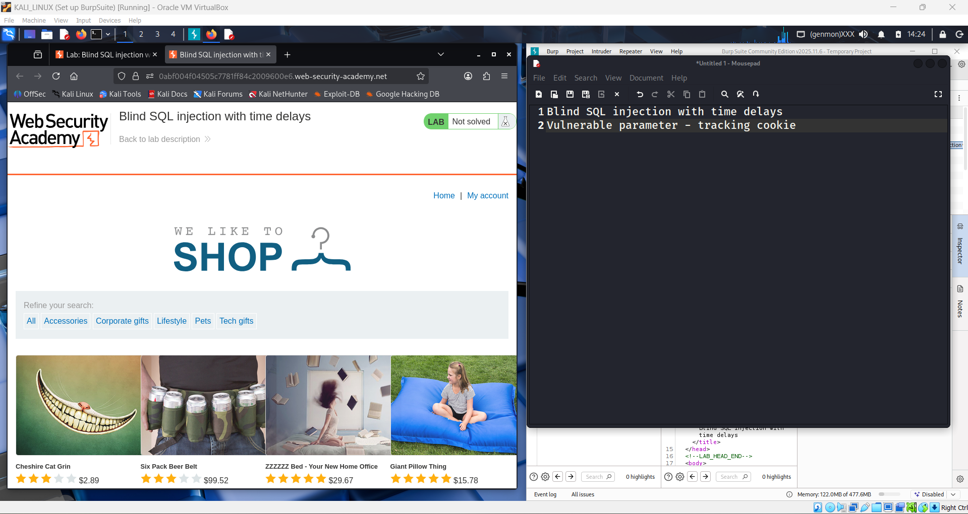

This screenshot shows the student continuing the “Blind SQL injection with time delays” lab in PortSwigger Web Security Academy on Kali Linux inside Oracle VirtualBox, with the vulnerable shop page open and Burp Suite Community Edition running; the notes now state the target is to prove the tracking cookie field is vulnerable to time-based blind SQL injection, meaning the student is at the analysis phase where they will intercept a request, modify the cookie with a delay payload, and compare response times to confirm the vulnerability before extracting data.
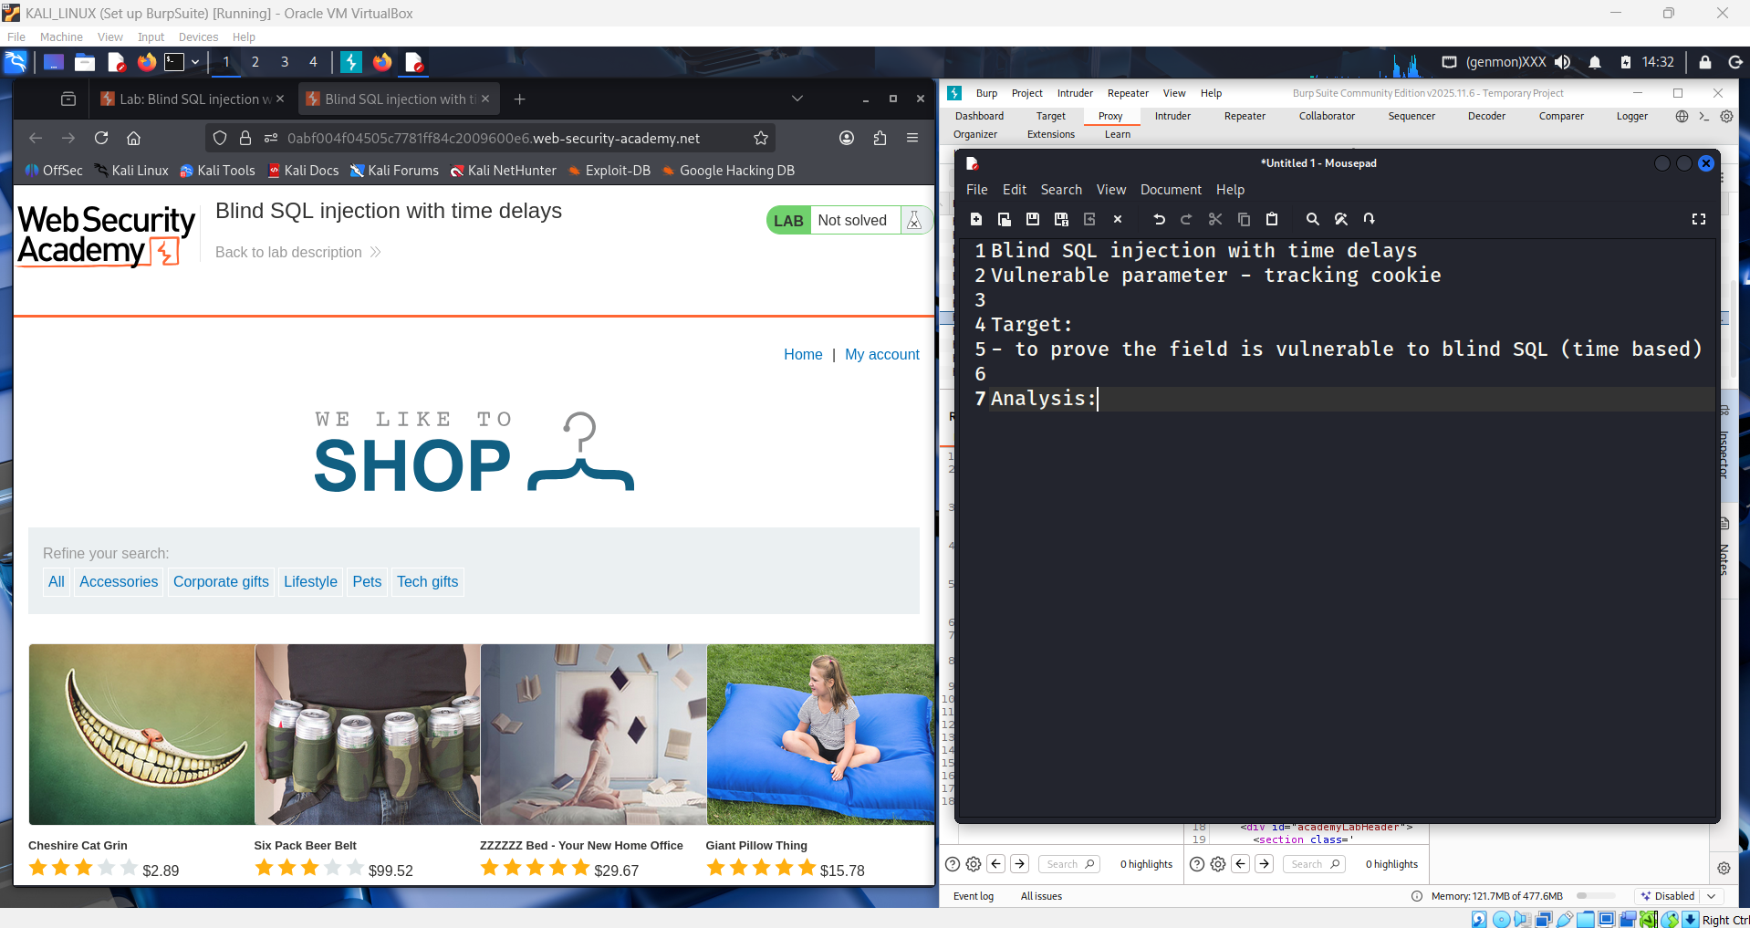

This screenshot shows the student actively intercepting traffic for the “Blind SQL injection with time delays” lab in PortSwigger Web Security Academy using Burp Suite Community Edition on Kali Linux inside Oracle VirtualBox; the Burp Proxy HTTP history displays captured requests to the lab site, and the selected request reveals the tracking cookie in the headers, meaning the student has successfully captured a normal request and identified where to inject the time-delay SQL payload, so the next step is to send this request to Repeater and modify the cookie value with a conditional SLEEP delay to observe if the response time increases and confirm the blind SQL injection point.

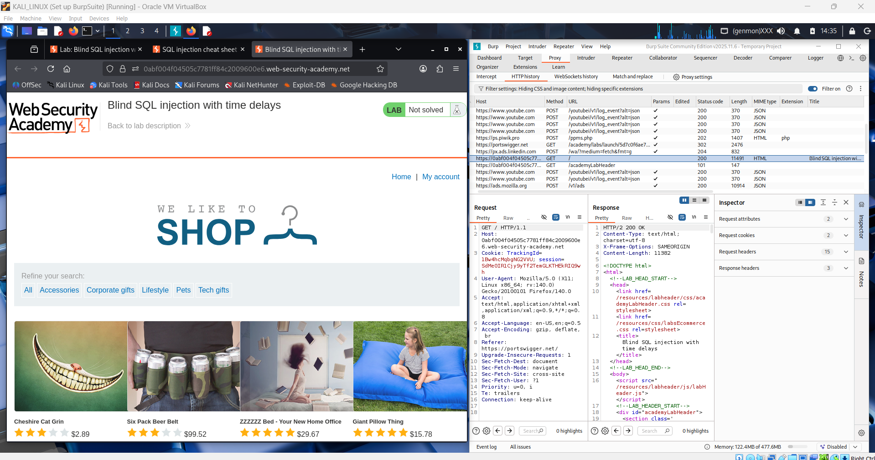

This screenshot shows the student sending the captured request to the Repeater tool in Burp Suite Community Edition while working on the “Blind SQL injection with time delays” lab from PortSwigger Web Security Academy on Kali Linux inside Oracle VirtualBox; the request with the tracking cookie is now loaded in Repeater, which means the student is preparing to manually edit the cookie value and insert a time-delay SQL payload, then repeatedly send the request and observe the response time to verify that the cookie parameter is vulnerable to time-based blind SQL injection.

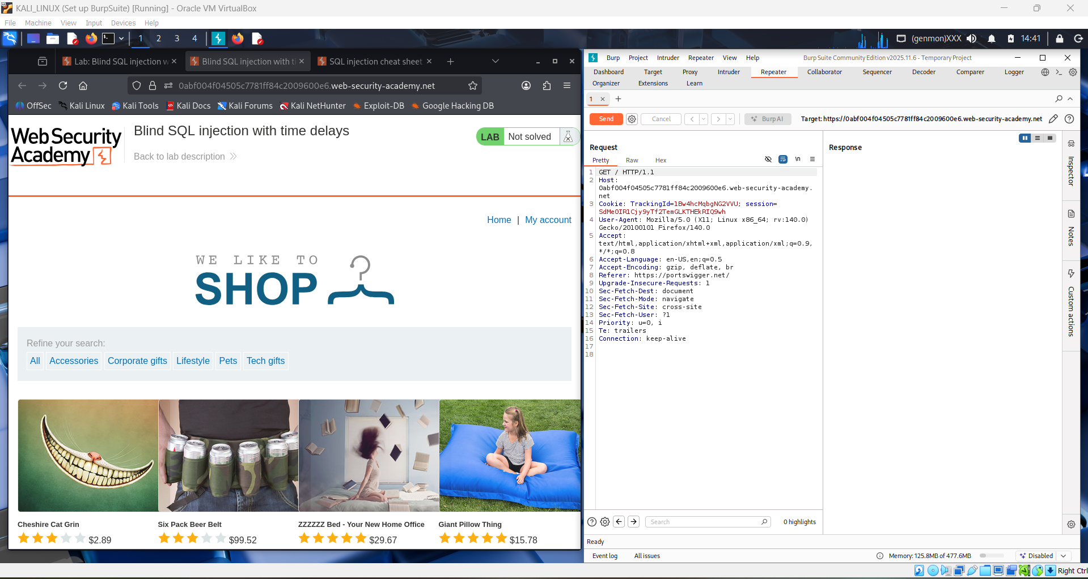

This screenshot shows the student researching time-delay payload syntax from the PortSwigger SQL injection cheat sheet while working on the “Blind SQL injection with time delays” lab in PortSwigger Web Security Academy using Burp Suite Community Edition on Kali Linux inside Oracle VirtualBox; on the left the cheat sheet shows MySQL time-delay functions like SELECT SLEEP(10), and on the right the student writes an injection payload '|| (SELECT SLEEP(10)) in their notes, meaning they are preparing a time-based SQL injection string to place into the tracking cookie in Burp Repeater to force a 10-second server delay and confirm the blind SQL injection vulnerability.

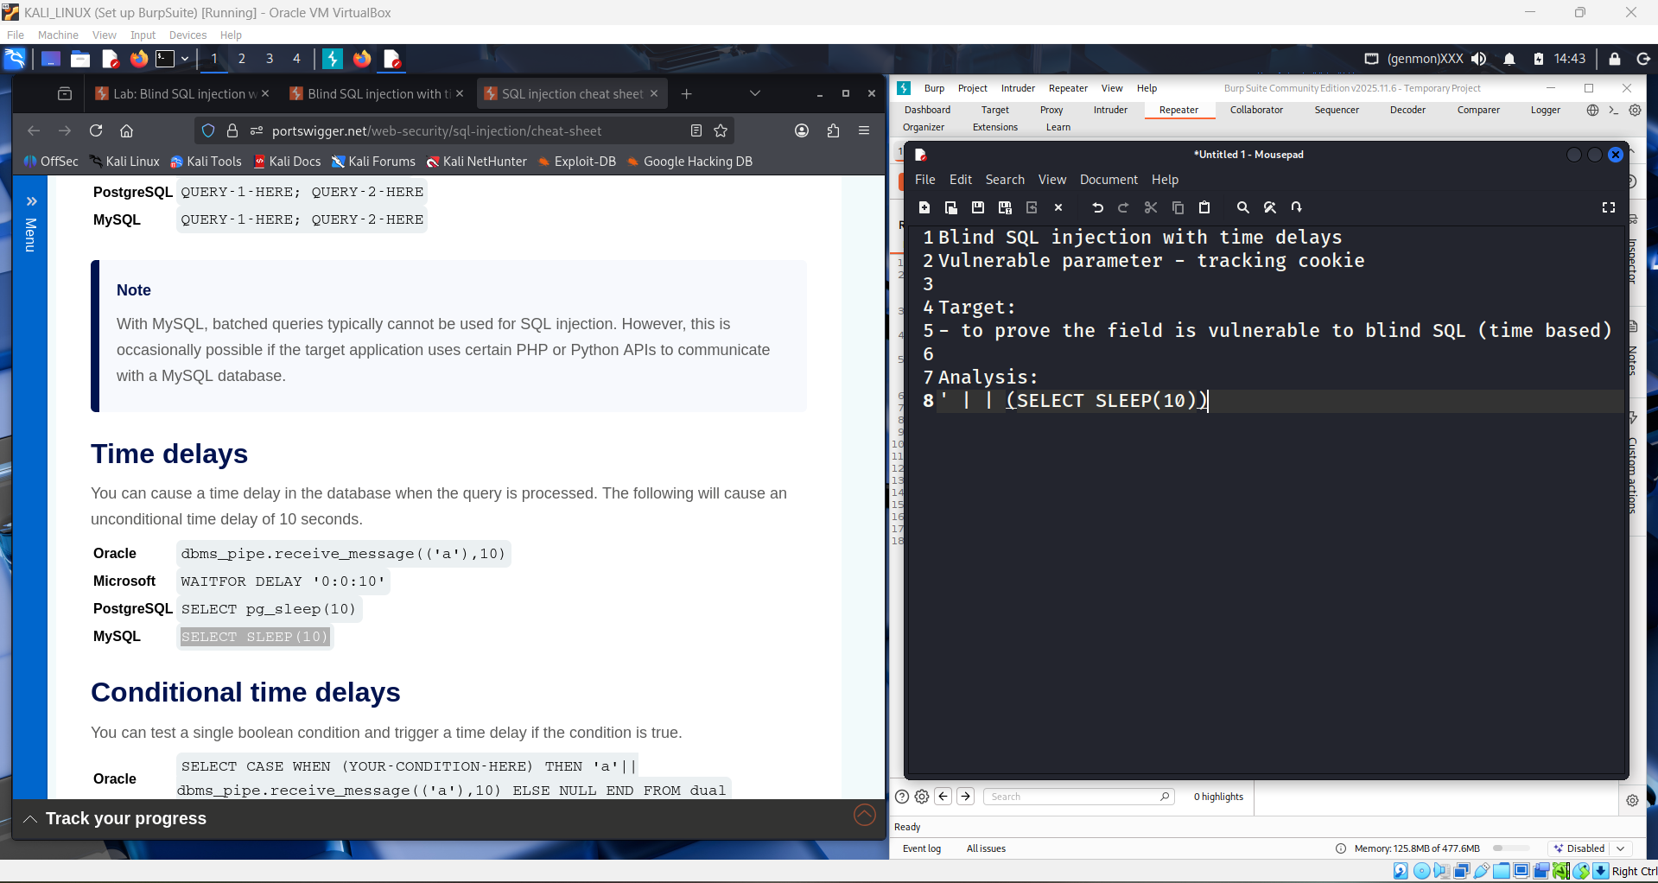

This screenshot shows the student inserting the prepared time-delay payload into the tracking cookie inside the Repeater tool of Burp Suite Community Edition while performing the “Blind SQL injection with time delays” lab from PortSwigger Web Security Academy on Kali Linux in Oracle VirtualBox; the cookie value now contains '||(SELECT SLEEP(10)), which means the student has modified the HTTP request to force a 10-second database delay, and the next step is to click Send and observe whether the server response time increases, confirming that the tracking cookie parameter is vulnerable to time-based blind SQL injection.

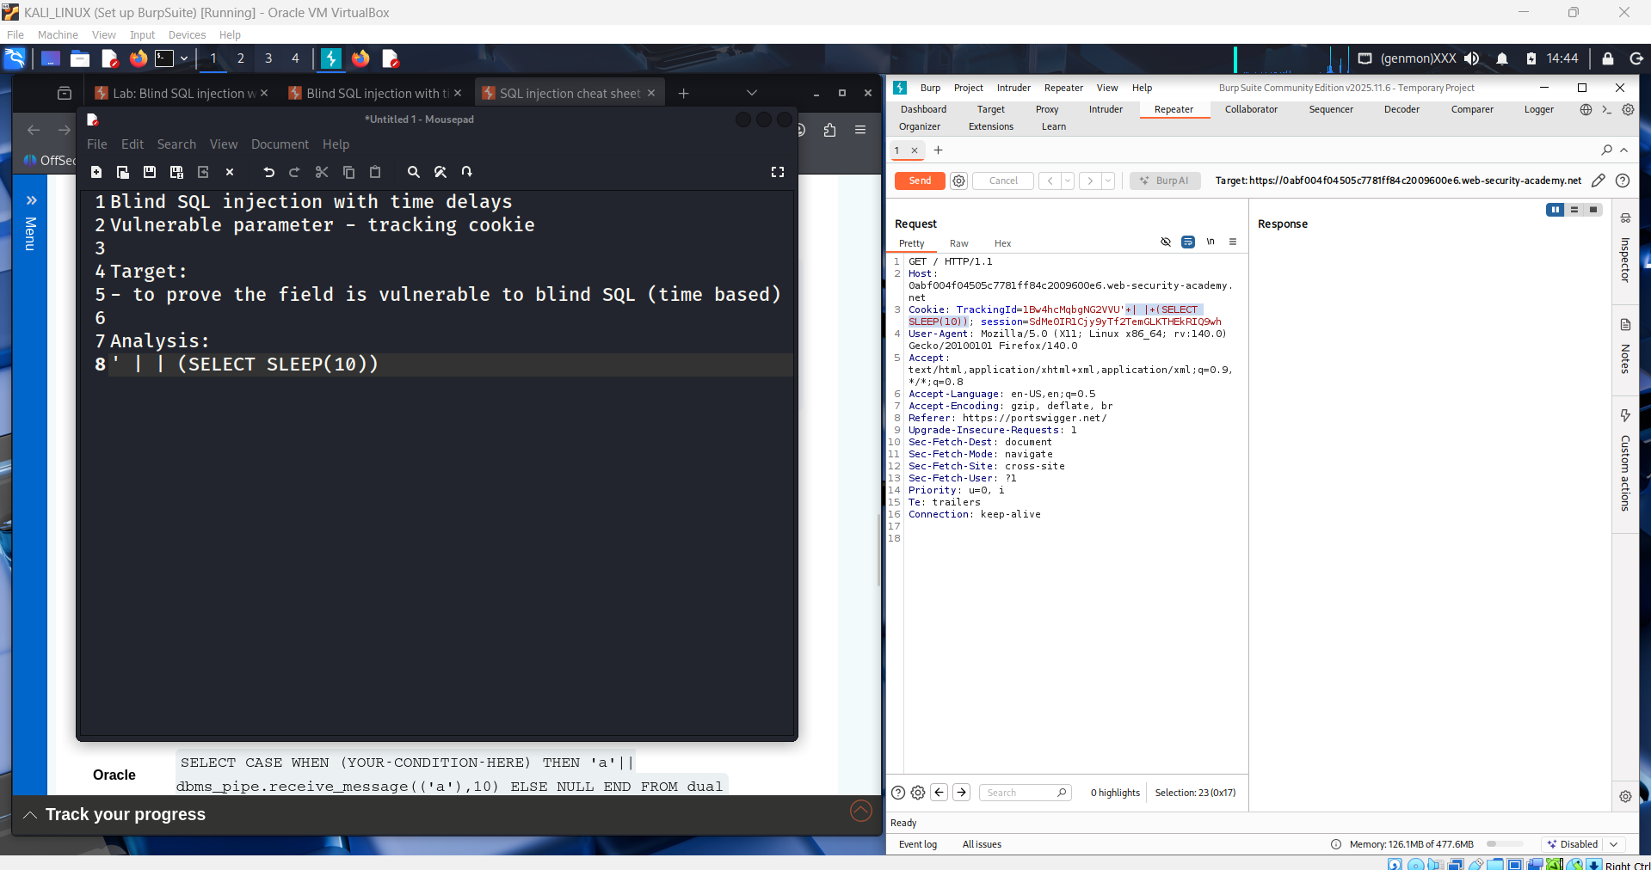

This screenshot shows the student sending the modified request with the time-delay payload in the tracking cookie through the Repeater of Burp Suite Community Edition while completing the “Blind SQL injection with time delays” lab from PortSwigger Web Security Academy on Kali Linux inside Oracle VirtualBox; the response is successfully returned after the request containing '||(SELECT SLEEP(10)), meaning the server accepted the injected SQL and delayed execution, which confirms that the tracking cookie parameter is vulnerable to time-based blind SQL injection and proves the injection point for further exploitation.

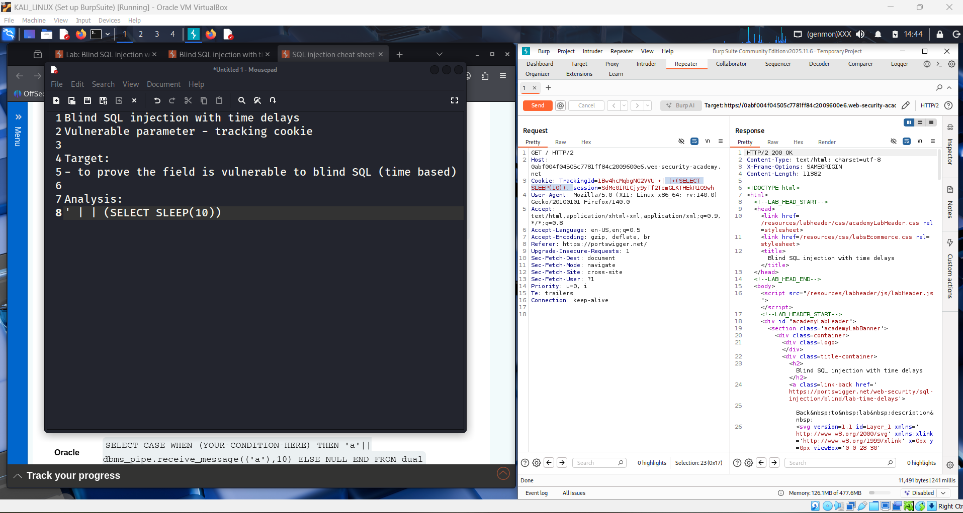

This screenshot shows the student repeating the request in the Repeater of Burp Suite Community Edition during the “Blind SQL injection with time delays” lab from PortSwigger Web Security Academy on Kali Linux inside Oracle VirtualBox; the tracking cookie still contains the injected payload and the response is returned after a noticeable delay, confirming consistently that the server executes the SLEEP(10) command, which verifies the blind time-based SQL injection vulnerability and shows the parameter can now be used for further data extraction steps.

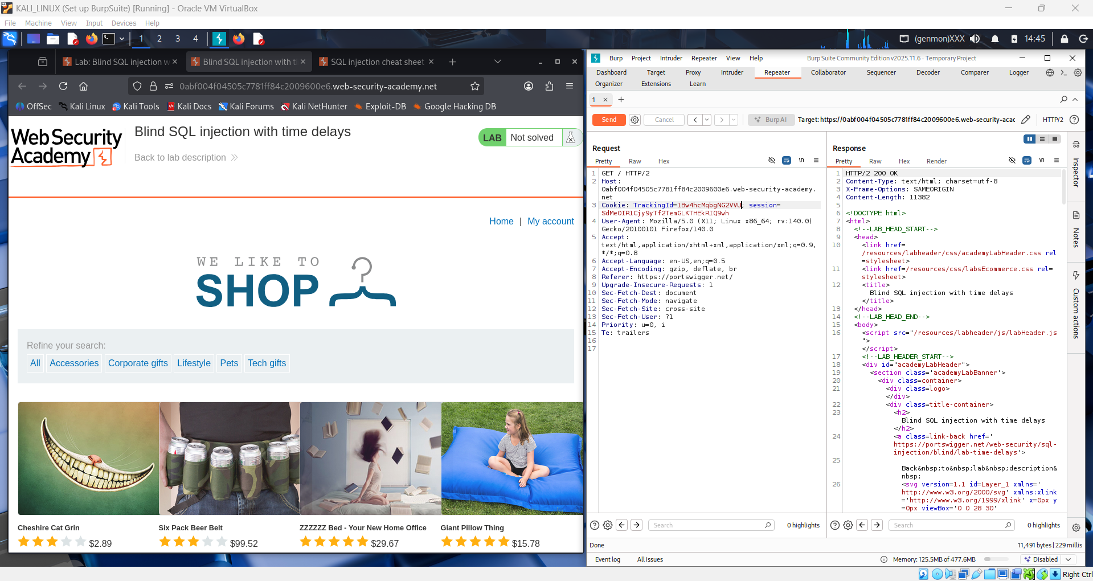

This screenshot shows the student testing different database-specific time-delay payloads in the Repeater of Burp Suite Community Edition while solving the “Blind SQL injection with time delays” lab from PortSwigger Web Security Academy on Kali Linux inside Oracle VirtualBox; in the notes the student first used the MySQL payload '||(SELECT SLEEP(10)) and then added the PostgreSQL version '||(SELECT pg_sleep(10)), and the cookie in the request now contains the pg_sleep function, meaning the student is checking which database engine the lab uses by observing if the server response still delays, which helps identify the backend DBMS and confirms the time-based blind SQL injection works across payload variations.

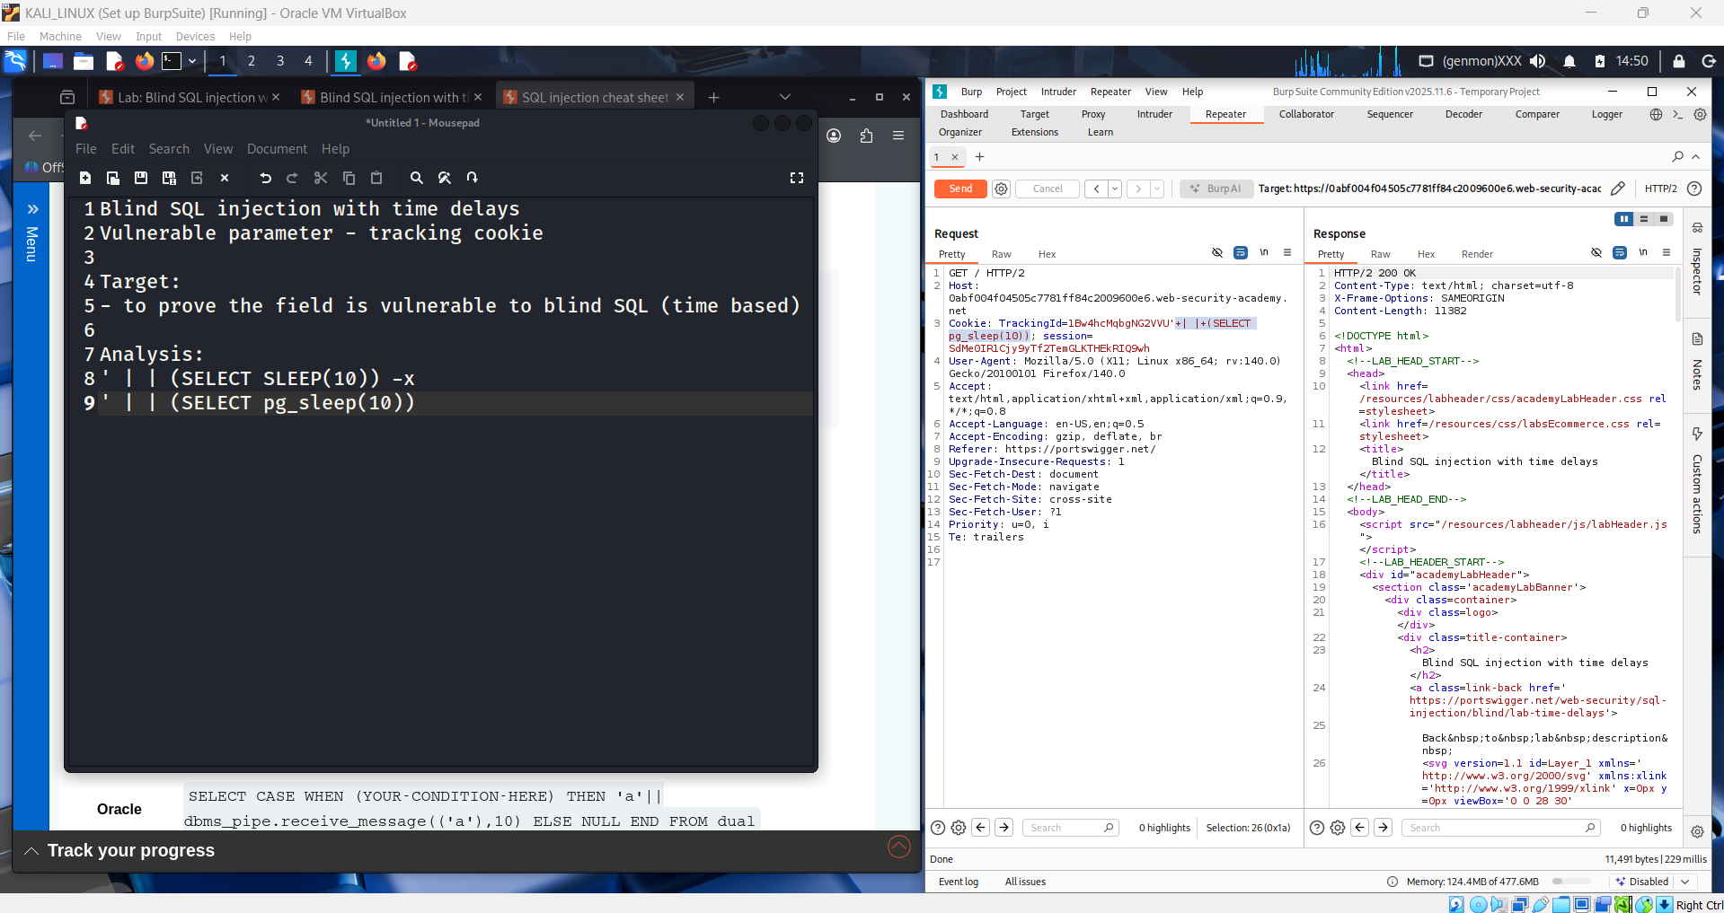

This screenshot shows the student documenting the SQL query context of the tracking cookie while continuing tests in the Repeater of Burp Suite Community Edition during the “Blind SQL injection with time delays” lab from PortSwigger Web Security Academy on Kali Linux inside Oracle VirtualBox; in the notes the student reconstructs the backend query select tracking-id from tracking-table where trackingid='…' and then appends the tested payloads like '||(SELECT SLEEP(10)) and '||(SELECT pg_sleep(10)), meaning they are analyzing how the injected cookie value is concatenated into the SQL statement, which explains why the time-delay payload executes successfully and confirms the injection point logic.

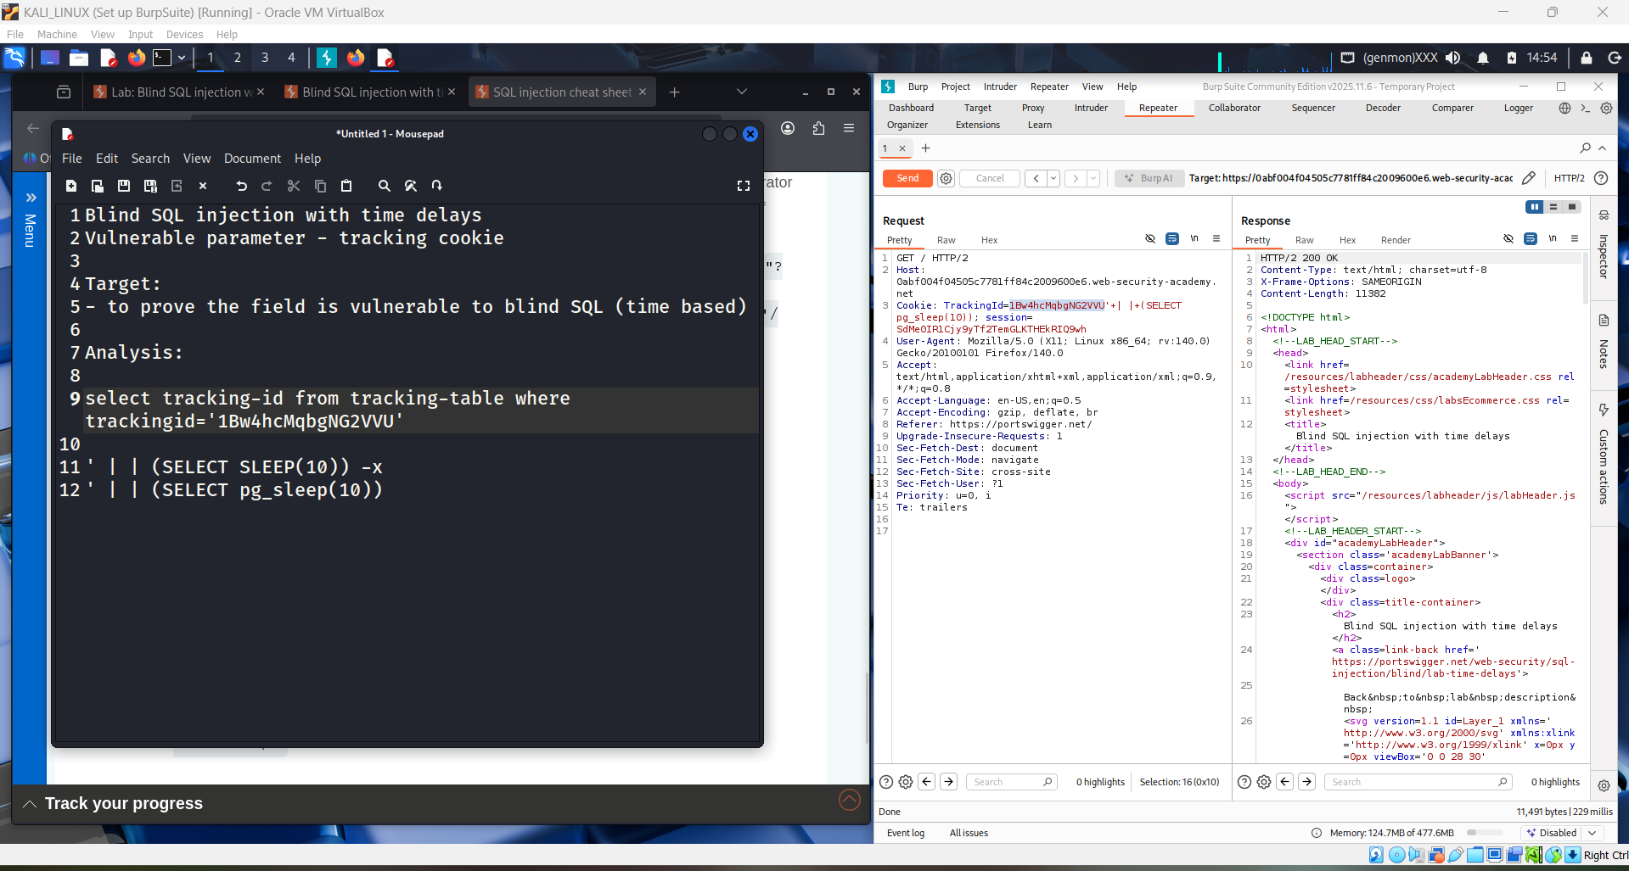

This screenshot shows the student finalizing the correct injection syntax in the Repeater of Burp Suite Community Edition during the “Blind SQL injection with time delays” lab from PortSwigger Web Security Academy on Kali Linux inside Oracle VirtualBox; in the notes they reconstruct the full backend query and append the payload as trackingid='…' || (SELECT SLEEP(10))--, adding the comment -- to ignore the rest of the original SQL, and the same payload appears in the cookie of the HTTP request, showing the student has correctly matched quotes, concatenation operator, and comment syntax so the time-delay executes reliably and proves the tracking cookie parameter is vulnerable to blind time-based SQL injection.

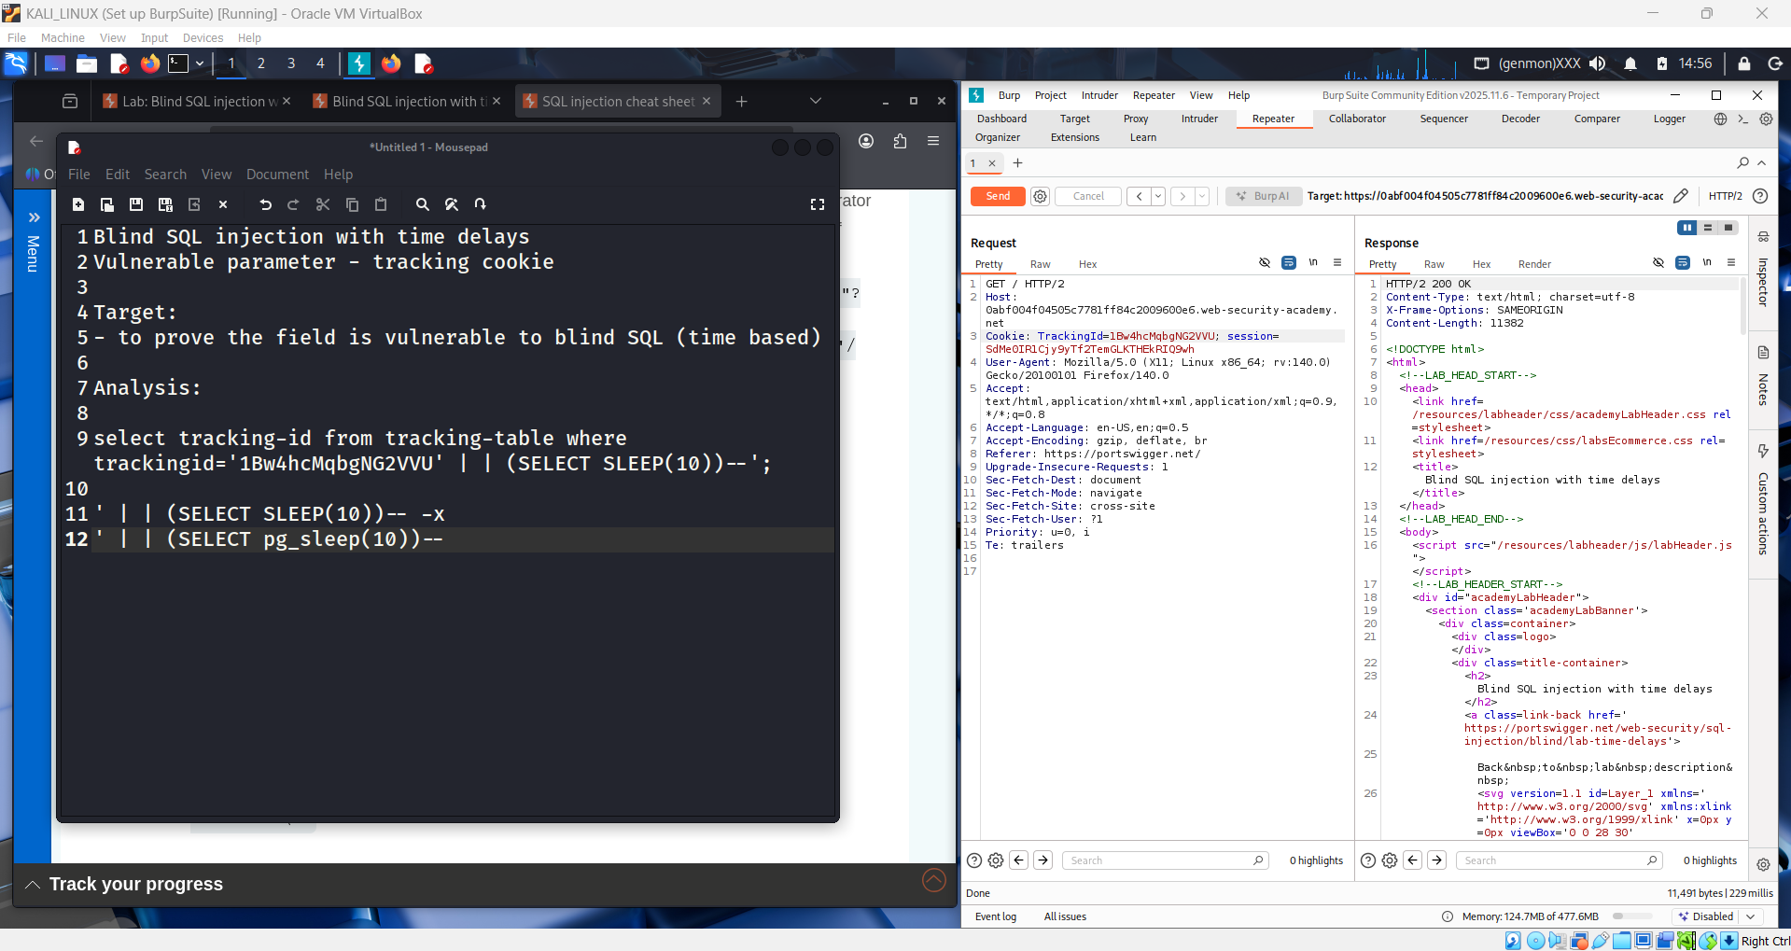

In this screenshot, the student has finalized a working time-based blind SQL injection payload in Burp Suite Community Edition while solving the “Blind SQL injection with time delays” lab from PortSwigger Web Security Academy.
They reconstructed the backend query:
select tracking-id from tracking-table where trackingid='1Bw4hcMqbgNG2VU'
Then injected:
' || (SELECT SLEEP(10))--
So the final query becomes:
where trackingid='1Bw4hcMqbgNG2VU' || (SELECT SLEEP(10))--
This payload closes the original string ('), adds a delay (SLEEP(10)), and comments out the rest (--).
Because the server response is delayed but still returns 200 OK, it confirms the tracking cookie is vulnerable to time-based blind SQL injection.

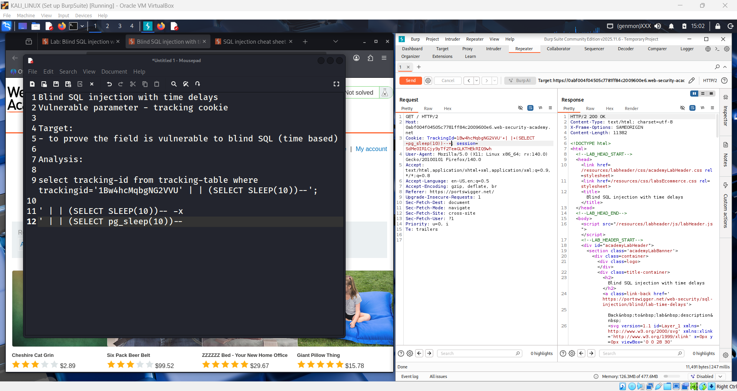

In this screenshot, the lab is already Solved, showing the student successfully exploited a time-based blind SQL injection in the tracking cookie using Burp Suite Community Edition.
They injected the payload:
' || (SELECT SLEEP(10))--
into the TrackingId cookie in Repeater.
This forces the database to pause for 10 seconds before responding. The delayed HTTP 200 OK response confirms the SQL query was executed, proving the cookie parameter is vulnerable.
So this step demonstrates the final confirmation of the blind SQL injection and completes the PortSwigger Web Security Academy lab.

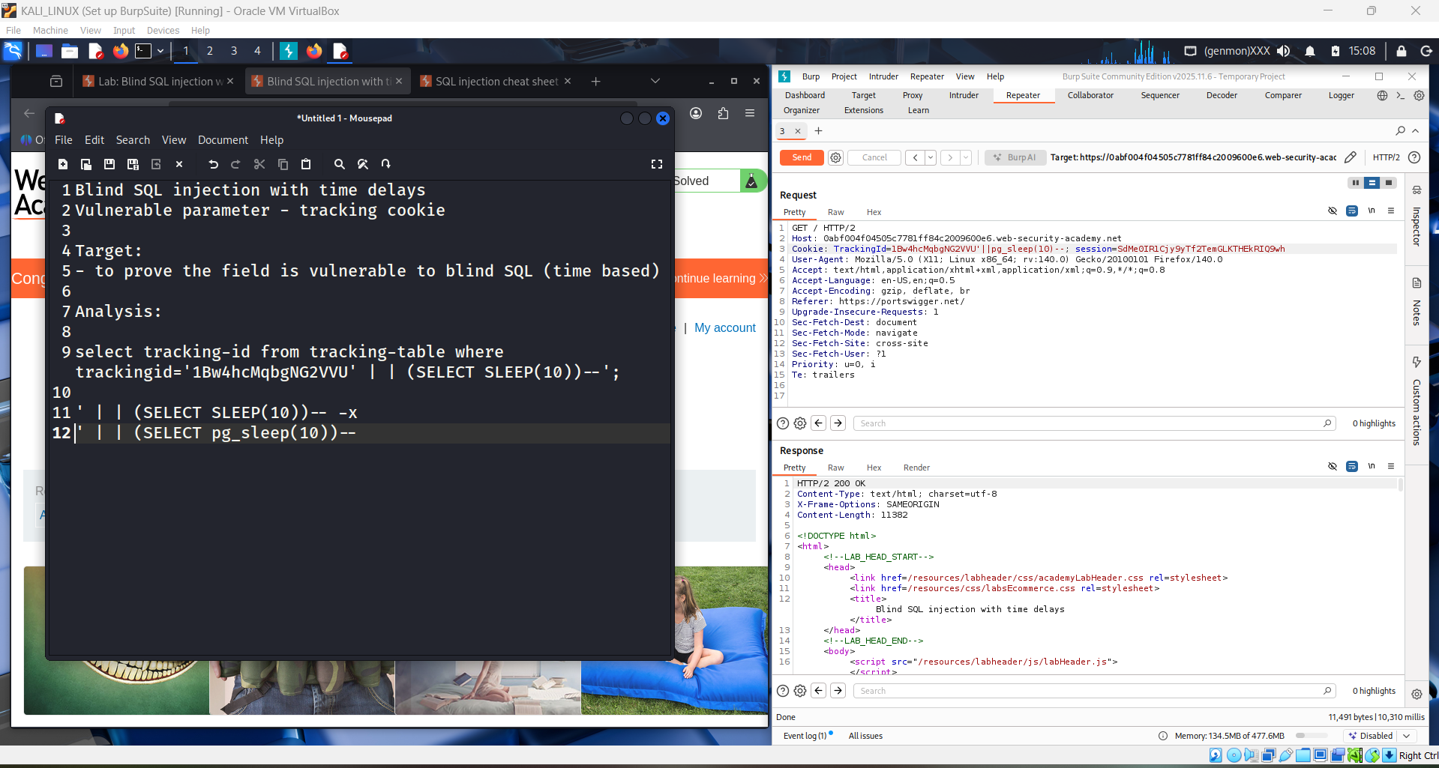

This screenshot shows that the Blind SQL Injection with time delays lab has been successfully completed on PortSwigger Web Security Academy.
On the left, the website displays “Congratulations, you solved the lab!”, meaning the attack worked.
On the right, in Burp Suite Community Edition Repeater, the student sent a request with a modified TrackingId cookie containing a time-delay payload (e.g., SLEEP(10)).
The server returned HTTP 200 OK after a delay, confirming the database executed the injected SQL.
So, the vulnerability is proven:
The TrackingId cookie is vulnerable to time-based blind SQL injection, and the lab is solved.
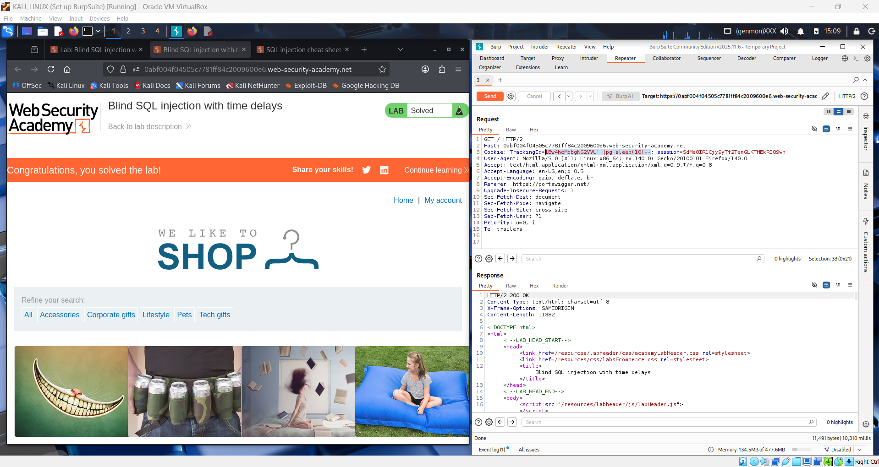

Conclusion
This lab demonstrates that the web application is vulnerable to SQL injection. By using crafted SQL payloads, an attacker can manipulate the backend query and retrieve unintended data from the database. This confirms that the application does not properly validate or sanitize user input, leading to a serious security vulnerability.

Q1. What is a Union-Based SQL Injection attack, and how does it differ from other types of SQL injection attacks?
A Union-Based SQL Injection attack is a technique that uses the SQL UNION operator to combine the results of a malicious query with the original database query. This allows attackers to directly extract data from the database and display it on the web page.
It differs from other SQL injection types, such as blind SQL injection, because union-based attacks return data visibly in the response, while blind SQL injection requires inference through true/false conditions or time delays.

Q2. Explain the role of the UNION SQL operator in this type of attack and how it can be used to extract data from a database that is not typically accessible.
The UNION operator combines the results of two SELECT queries into a single output. In a union-based SQL injection attack, the attacker injects an additional SELECT statement into the original query.
If the number and data types of columns match, the database returns both results together. This allows attackers to retrieve sensitive information, such as usernames and passwords, even though the application does not normally provide access to this data.

